***University Physics Volume I***

**Unit 1: Mechanics**

**Chapter 12: Static Equilibrium and Elasticity**

**Conceptual Questions**

1. What can you say about the velocity of a moving body that is in dynamic equilibrium?

Solution

constant

1. Under what conditions can a rotating body be in equilibrium? Give an example.

Solution

rotational velocity must be constant

1. What three factors affect the torque created by a force relative to a specific pivot point?

Solution

magnitude and direction of the force, and its lever arm

1. Mechanics sometimes put a length of pipe over the handle of a wrench when trying to remove a very tight bolt. How does this help?

Solution

Increase *r*, hence the torque.

For the next four problems, evaluate the statement as either true or false and explain your answer.

1. If there is only one external force (or torque) acting on an object, it cannot be in equilibrium.

Solution

True, as the sum of forces cannot be zero in this case unless the force itself is zero.

1. If an object is in equilibrium there must be an even number of forces acting on it.

Solution

False, provided forces add to zero as vectors then equilibrium can be achieved.

1. If an odd number of forces act on an object, the object cannot be in equilibrium.

Solution

False, provided forces add to zero as vectors then equilibrium can be achieved.

1. A body moving in a circle with a constant speed is in rotational equilibrium.

Solution

True, because its angular speed is constant too.

1. What purpose is served by a long and flexible pole carried by wire-walkers?

Solution

It helps a wire-walker to maintain equilibrium.

1. Is it possible to rest a ladder against a rough wall when the floor is frictionless?

Solution

No

1. Show how a spring scale and a simple fulcrum can be used to weigh an object whose weight is larger than the maximum reading on the scale.

Solution

proof

1. A painter climbs a ladder. Is the ladder more likely to slip when the painter is near the bottom or near the top?

Solution

near the top

*Note:* Unless stated otherwise, the weights of the wires, rods, and other elements are assumed to be negligible. Elastic moduli of selected materials are given in the following table.

|  |  |  |  |
| --- | --- | --- | --- |
| Material | Young’s modulus | Bulk modulus | Shear modulus |
| Aluminum | 7.0 | 7.5 | 2.5 |
| Bone (tension) | 1.6 | 0.8 | 8.0 |
| Bone (compression) | 0.9 |  |  |
| Brass | 9.0 | 6.0 | 3.5 |
| Brick | 1.5 |  |  |
| Concrete | 2.0 |  |  |
| Copper | 11.0 | 14.0 | 4.4 |
| Crown glass | 6.0 | 5.0 | 2.5 |
| Granite | 4.5 | 4.5 | 2.0 |
| Hair (human) | 1.0 |  |  |
| Hardwood | 1.5 |  | 1.0 |
| Iron | 21.0 | 16.0 | 7.7 |
| Lead | 1.6 | 4.1 | 0.6 |
| Marble | 6.0 | 7.0 | 2.0 |
| Nickel | 21.0 | 17.0 | 7.8 |
| Polystyrene | 3.0 |  |  |
| Silk | 6.0 |  |  |
| Spider thread | 3.0 |  |  |
| Steel | 20.0 | 16.0 | 7.5 |
| Acetone |  | 0.07 |  |
| Ethanol |  | 0.09 |  |
| Glycerin |  | 0.45 |  |
| Mercury |  | 2.5 |  |
| Water |  | 0.22 |  |

1. Why can a squirrel jump from a tree branch to the ground and run away undamaged, while a human could break a bone in such a fall?

Solution

In contact with the ground, stress in squirrel’s limbs is smaller than stress in human’s limbs.

1. When a glass bottle full of vinegar warms up, both the vinegar and the glass expand, but the vinegar expands significantly more with temperature than does the glass. The bottle will break if it is filled up to its very tight cap. Explain why and how a pocket of air above the vinegar prevents the bottle from breaking.

Solution

Air is more compressible than glass.

1. A thin wire strung between two nails in the wall is used to support a large picture. Is the wire likely to snap if it is strung tightly or if it is strung so that it sags considerably?

Solution

tightly

1. Review the relationship between stress and strain. Can you find any similarities between the two quantities?

Solution

they are different physical quantities

1. What type of stress are you applying when you press on the ends of a wooden rod? When you pull on its ends?

Solution

compressive; tensile

1. Can compressive stress be applied to a rubber band?

Solution

yes

1. Can Young’s modulus have a negative value? What about the bulk modulus?

Solution

no

1. If a hypothetical material has a negative bulk modulus, what happens when you squeeze a piece of it?

Solution

It would expand.

1. Discuss how you might measure the bulk modulus of a liquid.

Solution

Answers will vary.

*Note:* Unless stated otherwise, in the following two exercises, the weights of the wires, rods, and other elements are assumed to be negligible. Elastic moduli of selected materials are given in the table shown above.

1. What is meant when a fishing line is designated as “a 10-lb test?”

Solution

It breaks at a 10-lb load.

1. Steel rods are commonly placed in concrete before it sets. What is the purpose of these rods?

Solution

It acts as “reinforcement,” increasing a range of strain values before the structure reaches its breaking point.

**Problems**

1. When tightening a bolt, you push perpendicularly on a wrench with a force of 165 N at a distance of 0.140 m from the center of the bolt. How much torque are you exerting relative to the center of the bolt?

Solution

23.1 Nm

1. When opening a door, you push on it perpendicularly with a force of 55.0 N at a distance of 0.850 m from the hinges. What torque are you exerting relative to the hinges?

Solution

46.8 Nm

1. Find the magnitude of the tension in each supporting cable shown below. In each case, the weight of the suspended body is 100.0 N and the masses of the cables are negligible.

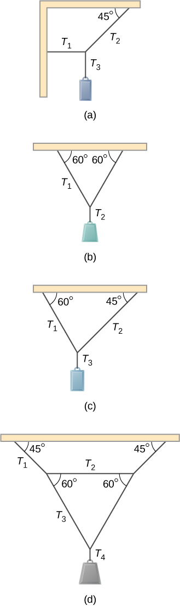

Solution

a. ; b. ;

c. ;

d. 

1. What force must be applied at point *P* to keep the structure shown in equilibrium? The weight of the structure is negligible.

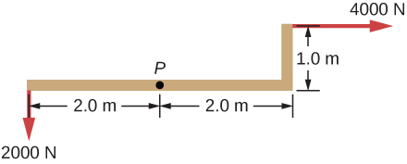

Solution

 in direction 

1. Is it possible to apply a force at *P* to keep in equilibrium the structure shown? The weight of the structure is negligible.

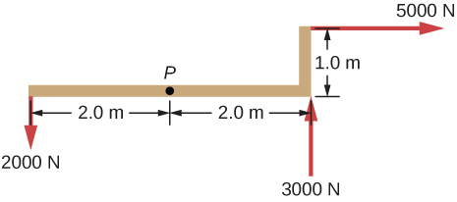

Solution

no

1. Two children push on opposite sides of a door during play. Both push horizontally and perpendicular to the door. One child pushes with a force of 17.5 N at a distance of 0.600 m from the hinges, and the second child pushes at a distance of 0.450 m. What force must the second child exert to keep the door from moving? Assume friction is negligible.

Solution

23.3 N

1. A small 1000-kg SUV has a wheel base of 3.0 m. If 60% if its weight rests on the front wheels, how far behind the front wheels is the wagon’s center of mass?

Solution

1.2 m

1. The uniform seesaw is balanced at its center of mass, as seen below. The smaller boy on the right has a mass of 40.0 kg. What is the mass of his friend?

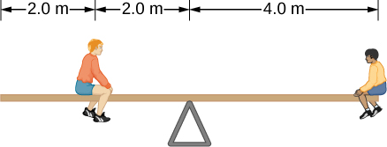

Solution

80.0 kg

1. A uniform plank rests on a level surface as shown below. The plank has a mass of 30 kg and is 6.0 m long. How much mass can be placed at its right end before it tips? (*Hint:* When the board is about to tip over, it makes contact with the surface only along the edge that becomes a momentary axis of rotation.)

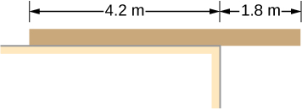

Solution

20 kg

1. The uniform seesaw shown below is balanced on a fulcrum located 3.0 m from the left end. The smaller boy on the right has a mass of 40 kg and the bigger boy on the left has a mass 80 kg. What is the mass of the board?

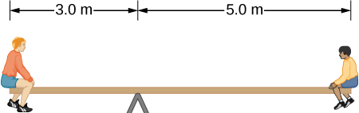

Solution

40 kg

1. In order to get his car out of the mud, a man ties one end of a rope to the front bumper and the other end to a tree 15 m away, as shown below. He then pulls on the center of the rope with a force of 400 N, which causes its center to be displaced 0.30 m, as shown. What is the force of the rope on the car?

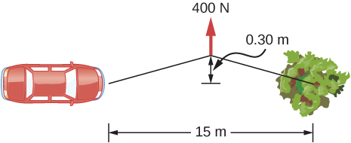

Solution



1. A uniform 40.0-kg scaffold of length 6.0 m is supported by two light cables, as shown below. An 80.0-kg painter stands 1.0 m from the left end of the scaffold, and his painting equipment is 1.5 m from the right end. If the tension in the left cable is twice that in the right cable, find the tensions in the cables and the mass of the equipment.

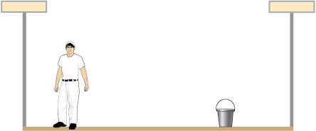

Solution

right cable, 444.3 N; left cable, 888.5 N; weight of equipment 156.8 N; 16.0 kg

1. When the structure shown below is supported at point *P*, it is in equilibrium. Find the magnitude of force *F* and the force applied at *P*. The weight of the structure is negligible.

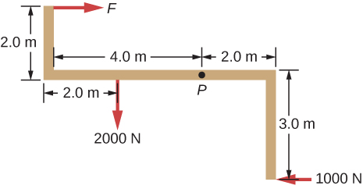

Solution

 in direction 

1. To get up on the roof, a person (mass 70.0 kg) places a 6.00-m aluminum ladder (mass 10.0 kg) against the house on a concrete pad with the base of the ladder 2.00 m from the house. The ladder rests against a plastic rain gutter, which we can assume to be frictionless. The center of mass of the ladder is 2.00 m from the bottom. The person is standing 3.00 m from the bottom. Find the normal reaction and friction forces on the ladder at its base.

Solution

784 N, 132.8 N

1. A uniform horizontal strut weighs 400.0 N. One end of the strut is attached to a hinged support at the wall, and the other end of the strut is attached to a sign that weighs 200.0 N. The strut is also supported by a cable attached between the end of the strut and the wall. Assuming that the entire weight of the sign is attached at the very end of the strut, find the tension in the cable and the force at the hinge of the strut.

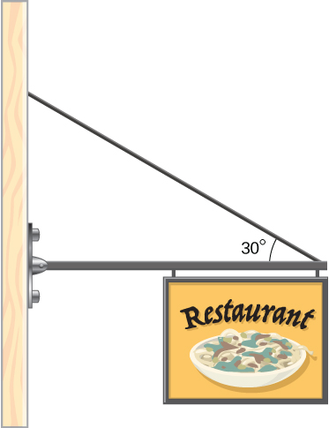

Solution

800 N, 721 N

1. The forearm shown below is positioned at an angle with respect to the upper arm, and a 5.0-kg mass is held in the hand. The total mass of the forearm and hand is 3.0 kg, and their center of mass is 15.0 cm from the elbow. (a) What is the magnitude of the force that the biceps muscle exerts on the forearm for  (b) What is the magnitude of the force on the elbow joint for the same angle? (c) How do these forces depend on the angle ?

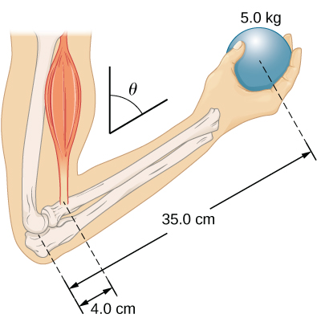

Solution

a. 539 N; b. 461 N; c. do not depend on the angle

1. The uniform boom shown below weighs 3000 N. It is supported by the horizontal guy wire and by the hinged support at point *A*. What are the forces on the boom due to the wire and due to the support at *A*? Does the force at *A* act along the boom?

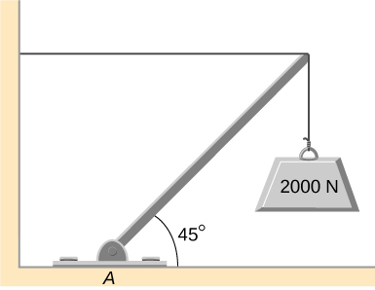

Solution

At *A*, ; no

1. The uniform boom shown below weighs 700 N, and the object hanging from its right end weighs 400 N. The boom is supported by a light cable and by a hinge at the wall. Calculate the tension in the cable and the force on the hinge on the boom. Does the force on the hinge act along the boom?

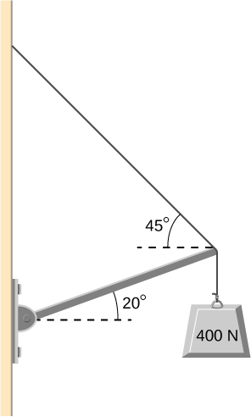

Solution

tension 778 N; at hinge 778 N at above the horizontal; no

1. A 12.0-m boom, *AB*, of a crane lifting a 3000-kg load is shown below. The center of mass of the boom is at its geometric center, and the mass of the boom is 1000 kg. For the position shown, calculate tension *T* in the cable and the force at the axle *A*.

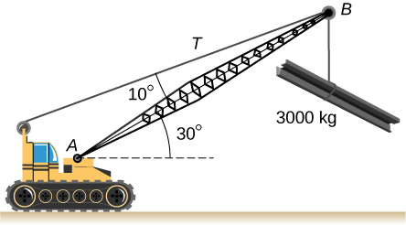

Solution

tension, 

1. A uniform trapdoor shown below is 1.0 m by 1.5 m and weighs 300 N. It is supported by a single hinge (H), and by a light rope tied between the middle of the door and the floor. The door is held at the position shown, where its slab makes a  angle with the horizontal floor and the rope makes a  angle with the floor. Find the tension in the rope and the force at the hinge.

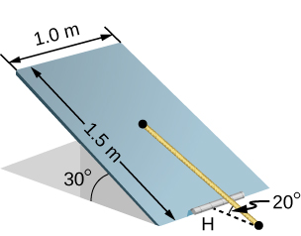

Solution

1500 N; 1620 N at 

1. A 90-kg man walks on a sawhorse, as shown below. The sawhorse is 2.0 m long and 1.0 m high, and its mass is 25.0 kg. Calculate the normal reaction force on each leg at the contact point with the floor when the man is 0.5 m from the far end of the sawhorse. (*Hint:* At each end, find the total reaction force first. This reaction force is the vector sum of two reaction forces, each acting along one leg. The normal reaction force at the contact point with the floor is the normal (with respect to the floor) component of this force.)

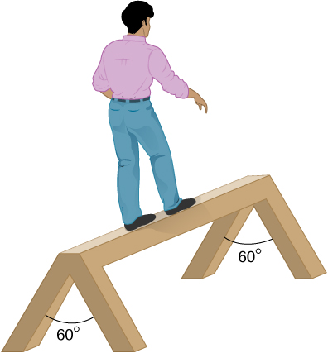

Solution

at each leg at the far end, 171.5 N; at each leg at the other end 392.0 N

1. The “lead” in pencils is a graphite composition with a Young’s modulus of approximately . Calculate the change in length of the lead in an automatic pencil if you tap it straight into the pencil with a force of 4.0 N. The lead is 0.50 mm in diameter and 60 mm long.

Solution

1.2 mm

1. TV broadcast antennas are the tallest artificial structures on Earth. In 1987, a 72.0-kg physicist placed himself and 400 kg of equipment at the top of a 610-m-high antenna to perform gravity experiments. By how much was the antenna compressed, if we consider it to be equivalent to a steel cylinder 0.150 m in radius?

Solution

0.200 mm

1. By how much does a 65.0-kg mountain climber stretch her 0.800-cm diameter nylon rope when she hangs 35.0 m below a rock outcropping? (For nylon, 

Solution

32.9 cm

1. When water freezes, its volume increases by 9.05%. What force per unit area is water capable of exerting on a container when it freezes?

Solution

200 MPa

1. A farmer making grape juice fills a glass bottle to the brim and caps it tightly. The juice expands more than the glass when it warms up, in such a way that the volume increases by 0.2%. Calculate the force exerted by the juice per square centimeter if its bulk modulus is , assuming the bottle does not break.

Solution



1. A disk between vertebrae in the spine is subjected to a shearing force of 600.0 N. Find its shear deformation, using the shear modulus of . The disk is equivalent to a solid cylinder 0.700 cm high and 4.00 cm in diameter.

Solution



1. A vertebra is subjected to a shearing force of 500.0 N. Find the shear deformation, taking the vertebra to be a cylinder 3.00 cm high and 4.00 cm in diameter. How does your result compare with the result obtained in the preceding problem? Are spinal problems more common in disks than in vertebrae?

Solution



1. Calculate the force a piano tuner applies to stretch a steel piano wire by 8.00 mm, if the wire is originally 1.35 m long and its diameter is 0.850 mm.

Solution

673 N

1. A 20.0-m-tall hollow aluminum flagpole is equivalent in strength to a solid cylinder 4.00 cm in diameter. A strong wind bends the pole as much as a horizontal 900.0-N force on the top would do. How far to the side does the top of the pole flex?

Solution

0.57 mm

1. A copper wire of diameter 1.0 cm stretches 1.0% when it is used to lift a load upward with an acceleration of . What is the weight of the load?

Solution

73 kN

1. As an oil well is drilled, each new section of drill pipe supports its own weight and the weight of the pipe and the drill bit beneath it. Calculate the stretch in a new 6.00-m-long steel pipe that supports a 100-kg drill bit and a 3.00-km length of pipe with a linear mass density of 20.0 kg/m. Treat the pipe as a solid cylinder with a 5.00-cm diameter.

Solution

8.59 mm

1. A large uniform cylindrical steel rod of density  is 2.0 m long and has a diameter of 5.0 cm. The rod is fastened to a concrete floor with its long axis vertical. What is the normal stress in the rod at the cross-section located at (a) 1.0 m from its lower end? (b) 1.5 m from the lower end?

Solution

a. 76.44 kPa; b. 38.22 kPa

1. A 90-kg mountain climber hangs from a nylon rope and stretches it by 25.0 cm. If the rope was originally 30.0 m long and its diameter is 1.0 cm, what is Young’s modulus for the nylon?

Solution



1. A suspender rod of a suspension bridge is 25.0 m long. If the rod is made of steel, what must its diameter be so that it does not stretch more than 1.0 cm when a  truck passes by it? Assume that the rod supports all of the weight of the truck.

Solution

6.24 cm

1. A copper wire is 1.0 m long and its diameter is 1.0 mm. If the wire hangs vertically, how much weight must be added to its free end in order to stretch it 3.0 mm?

Solution

259.0 N

1. A 100-N weight is attached to a free end of a metallic wire that hangs from the ceiling. When a second 100-N weight is added to the wire, it stretches 3.0 mm. The diameter and the length of the wire are 1.0 mm and 2.0 m, respectively. What is Young’s modulus of the metal used to manufacture the wire?

Solution



1. The bulk modulus of a material is . What fractional change in volume does a piece of this material undergo when it is subjected to a bulk stress increase of ? Assume that the force is applied uniformly over the surface.

Solution

0.01%

1. Normal forces of magnitude  are applied uniformly to a spherical surface enclosing a volume of a liquid. This causes the radius of the surface to decrease from 50.000 cm to 49.995 cm. What is the bulk modulus of the liquid?

Solution



1. During a walk on a rope, a tightrope walker creates a tension of  in a wire that is stretched between two supporting poles that are 15.0 m apart. The wire has a diameter of 0.50 cm when it is not stretched. When the walker is on the wire in the middle between the poles the wire makes an angle of  below the horizontal. How much does this tension stretch the steel wire when the walker is this position?

Solution

1.44 cm

1. When using a pencil eraser, you exert a vertical force of 6.00 N at a distance of 2.00 cm from the hardwood-eraser joint. The pencil is 6.00 mm in diameter and is held at an angle of  to the horizontal. (a) By how much does the wood flex perpendicular to its length? (b) How much is it compressed lengthwise?

Solution

When using a pencil eraser, you exert a vertical force of 6.00 N at a distance of 2.00 cm from the hardwood-eraser joint. The pencil is 6.00 mm in diameter and is held at an angle of  to the horizontal. (a) By how much does the wood flex perpendicular to its length? (b) How much is it compressed lengthwise?

1. Normal forces are applied uniformly over the surface of a spherical volume of water whose radius is 20.0 cm. If the pressure on the surface is increased by 200 MPa, by how much does the radius of the sphere decrease?

Solution

0.63 cm

1. A uniform rope of cross-sectional area  breaks when the tensile stress in it reaches  (a) What is the maximum load that can be lifted slowly at a constant speed by the rope? (b) What is the maximum load that can be lifted by the rope with an acceleration of?

Solution

a. 300 N; b. 213 N

1. One end of a vertical metallic wire of length 2.0 m and diameter 1.0 mm is attached to a ceiling, and the other end is attached to a 5.0-N weight pan, as shown below. The position of the pointer before the pan is 4.000 cm. Different weights are then added to the pan area, and the position of the pointer is recorded in the table shown. Plot stress versus strain for this wire, then use the resulting curve to determine Young’s modulus and the proportionality limit of the metal. What metal is this most likely to be?

|  |  |
| --- | --- |
| Added load (including pan)  (N) | Scale reading  (cm) |
| 0 | 4.000 |
| 15 | 4.036 |
| 25 | 4.073 |
| 35 | 4.109 |
| 45 | 4.146 |
| 55 | 4.181 |
| 65 | 4.221 |
| 75 | 4.266 |
| 85 | 4.316 |

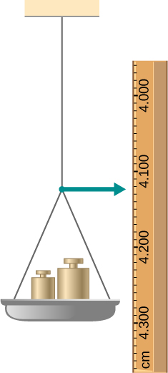

1. An aluminum () wire is suspended from the ceiling and hangs vertically. How long must the wire be before the stress at its upper end reaches the proportionality limit, which is ?

Solution

3020 m

**Additional Problems**

1. The coefficient of static friction between the rubber eraser of the pencil and the tabletop is. If the force  is applied along the axis of the pencil, as shown below, what is the minimum angle at which the pencil can stand without slipping? Ignore the weight of the pencil.

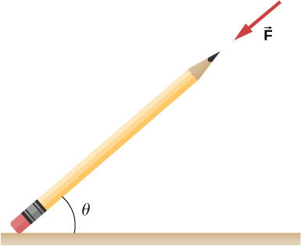

Solution



1. A pencil rests against a corner, as shown below. The sharpened end of the pencil touches a smooth vertical surface and the eraser end touches a rough horizontal floor. The coefficient of static friction between the eraser and the floor is . The center of mass of the pencil is located 9.0 cm from the tip of the eraser and 11.0 cm from the tip of the pencil lead. Find the minimum angle  for which the pencil does not slip.

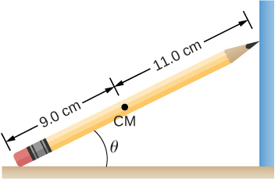

Solution



1. A uniform 4.0-m plank weighing 200.0 N rests against the corner of a wall, as shown below. There is no friction at the point where the plank meets the corner. (a) Find the forces that the corner and the floor exert on the plank. (b) What is the minimum coefficient of static friction between the floor and the plank to prevent the plank from slipping?

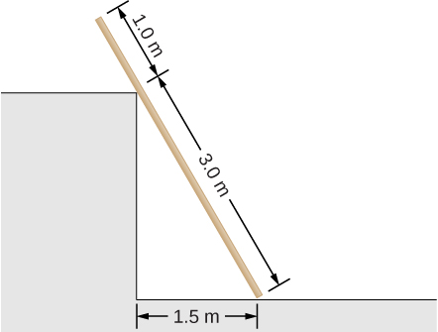

Solution

a. at corner 66.7 N at  with the horizontal; at floor 177 N at  with the horizontal; b. 

1. A 40-kg boy jumps from a height of 3.0 m, lands on one foot and comes to rest in 0.10 s after he hits the ground. Assume that he comes to rest with a constant acceleration opposite to the motion. If the total cross-sectional area of the bones in his legs just above his ankles is , what is the compression stress in these bones? Leg bones can be fractured when they are subjected to stress greater than . Is the boy in danger of breaking his leg?

Solution

; no

1. Two thin rods, one made of steel and the other of aluminum, are joined end to end. Each rod is 2.0 m long and has cross-sectional area . If a 10,000-N tensile force is applied at each end of the combination, find: (a) stress in each rod; (b) strain in each rod; and, (c) elongation of each rod.

Solution

a.; b. ; c. 11.0 mm, 31.4 mm

1. Two rods, one made of copper and the other of steel, have the same dimensions. If the copper rod stretches by 0.15 mm under some stress, how much does the steel rod stretch under the same stress?

Solution



**Challenge Problems**

1. A horizontal force  is applied to a uniform sphere in direction exact toward the center of the sphere, as shown below. Find the magnitude of this force so that the sphere remains in static equilibrium. What is the frictional force of the incline on the sphere?

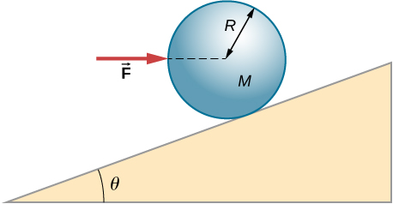

Solution



1. When a motor is set on a pivoted mount seen below, its weight can be used to maintain tension in the drive belt. When the motor is not running the tensions  and  are equal. The total mass of the platform and the motor is 100.0 kg, and the diameter of the drive belt pulley is 16.0 cm. when the motor is off, find: (a) the tension in the belt, and (b) the force at the hinged platform support at point *C*. Assume that the center of mass of the motor plus platform is at the center of the motor.

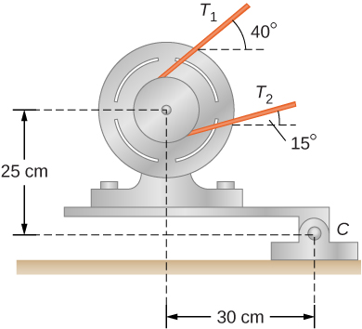

Solution

a. 419 N; b. 942 N at 

1. Two wheels *A* and *B* with weights *w* and 2*w*, respectively, are connected by a uniform rod with weight *w*/2, as shown below. The wheels are free to roll on the sloped surfaces. Determine the angle that the rod forms with the horizontal when the system is in equilibrium. *Hint:* There are five forces acting on the rod, which is two weights of the wheels, two normal reaction forces at points where the wheels make contacts with the wedge, and the weight of the rod.

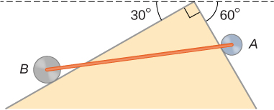

Solution

with the horizontal, ;  with the steeper side of the wedge

1. Weights are gradually added to a pan until a wheel of mass *M* and radius *R* is pulled over an obstacle of height *d*, as shown below. What is the minimum mass of the weights plus the pan needed to accomplish this?

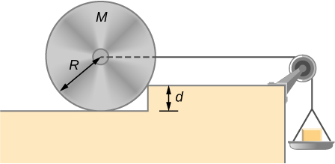

Solution



1. In order to lift a shovelful of dirt, a gardener pushes downward on the end of the shovel and pulls upward at distance  from the end, as shown below. The weight of the shovel is  and acts at the point of application of . Calculate the magnitudes of the forces  and  as functions of , , *mg*, and the weight *W* of the load. Why do your answers not depend on the angle that the shovel makes with the horizontal?

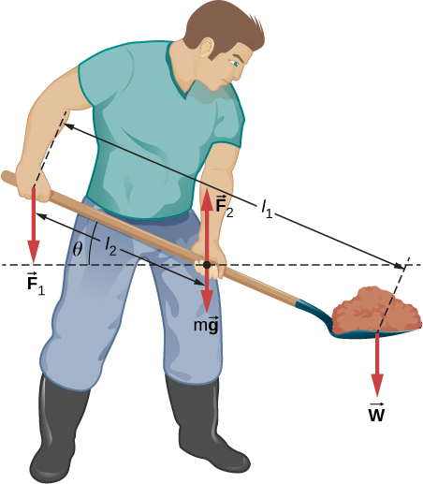

Solution



1. A uniform rod of length *2R* and mass *M*  is attached to a small collar *C* and rests on a cylindrical surface of radius *R*, as shown below. If the collar can slide without friction along the vertical guide, find the angle  for which the rod is in static equilibrium.

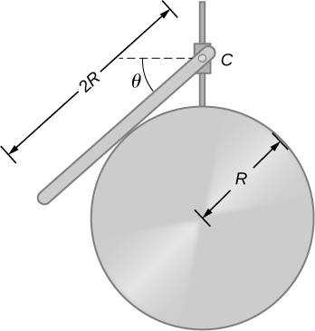

Solution



1. The pole shown below is at a  bend in a power line and is therefore subjected to more shear force than poles in straight parts of the line. The tension in each line is , at the angles shown. The pole is 15.0 m tall, has an 18.0 cm diameter, and can be considered to have half the strength of hardwood. (a) Calculate the compression of the pole. (b) Find how much it bends and in what direction. (c) Find the tension in a guy wire used to keep the pole straight if it is attached to the top of the pole at an angle of  with the vertical. The guy wire is in the opposite direction of the bend.

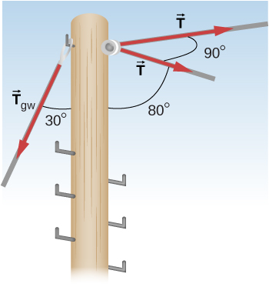

Solution

a. 1.1 mm; b. 6.6 mm to the right; c. 

This file is copyright 2016, Rice University. All Rights Reserved.